**Intro**

So far we’ve used NodeJS and some basic JavaScript to control the drone, however this is a bit static – what if we want to perform different commands during flight? Or what if we want to view a live feed from the drone? This is where Webflight comes in.

Webflight is a great open-source project provided by Laurent Eschenauer (<https://github.com/eschnou>), the repo can be found here (<https://github.com/eschnou/ardrone-webflight>). This program allows the user to manually control the drone using their computer keyboard while viewing a live feed through the web browser and comes with several interesting plugins.

**Install Webflight**

Scrolling down a bit on the Webflight github page you’ll see the below instructions for installation. The yellow highlighted line has been added by me as I found that bower wasn’t recognised by the computer without this (bower install will fail, unknown command). Run these commands in a command prompt window in a location of your choice, I personally used the git bash window I’m using for version control to complete the below and it worked fine.

git clone https://github.com/eschnou/ardrone-webflight.git

cd ardrone-webflight

npm install

npm install bower –g additional step as it doesn’t recognise bower without

bower install

The three screenshots below demonstrate the process of installing everything, and installing bower using npm, using the –g tag to set a global path variable to it as well (this just means that you can run the command ‘bower’ anywhere and it’ll be recognised, rather than having to run it from the directory it lives in).

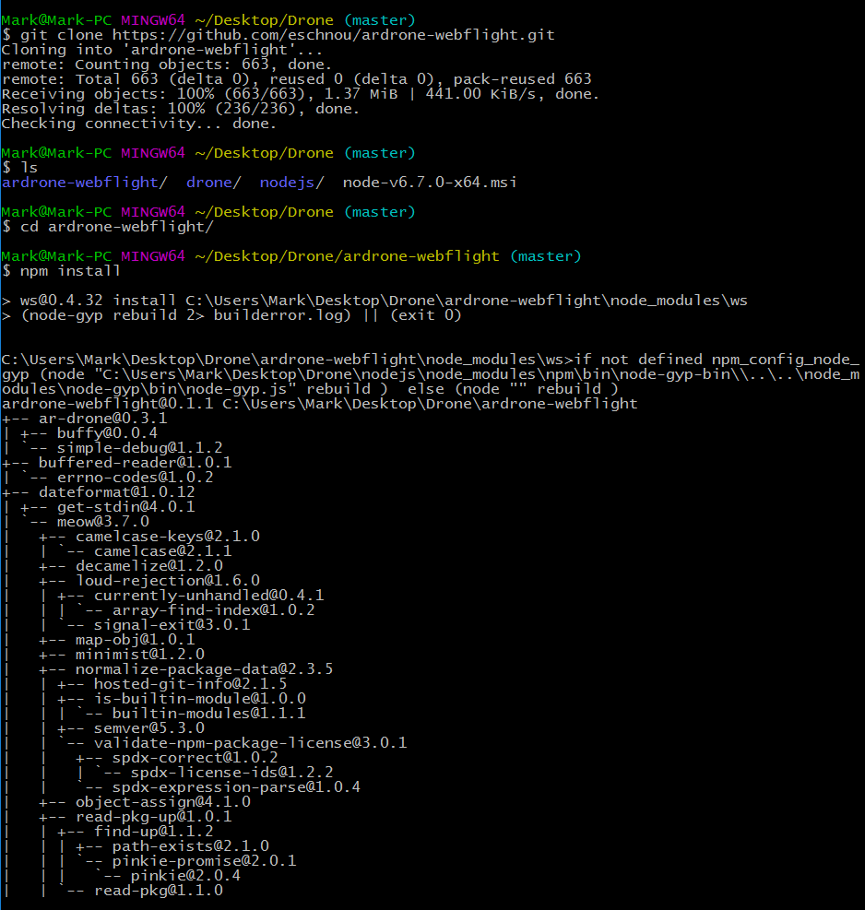

Figure 1: Cloning repo from GitHub and using npm install

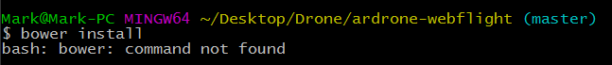

Figure 2: At first your computer will not understand what bower 'is'

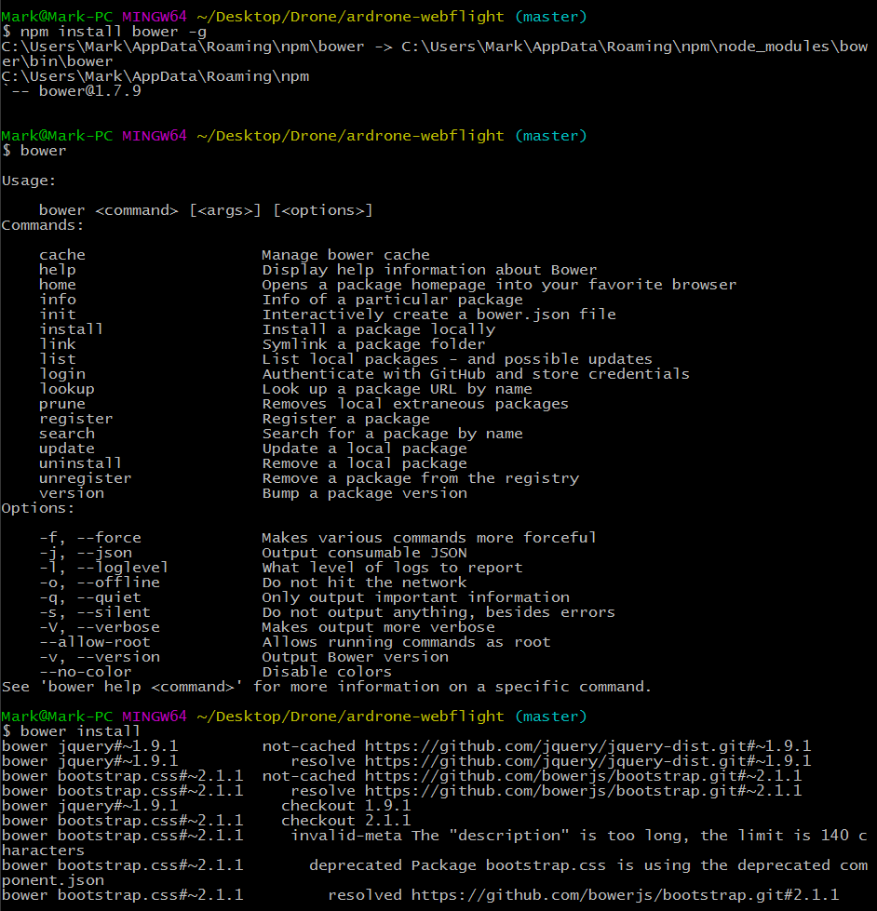

Figure 3: Use npm to install bower and use the -g tag to set it to global path, bower is now recognised and you can run bower install

**Configuration**

Now that everything is installed we need to make sure that Webflight is configured as we like it. To get a basic level of operation running we won’t need to do much so we’ll do the bare minimum for now to get up and running.

If you navigate to the ardrone-webflight folder that you recently cloned from GitHub, you’ll find a file called config.js.EXAMPLE – simply put this is your configuration file that tells Webflight which plugins to use etc. For now, rename the file to config.js (remove the ‘.EXAMPLE’ bit at the end), so as it’s recognised as the correct file for Webflight to use. Aside from config.js, there is one other file in the same directory that is very important, that being app.js. App.js is the main, central JavaScript program that includes links to the config.js file (hence why renaming this a minute ago was important!) as well as basic controls etc. There’s no need to edit this right now, that’s the basic configuration done!

If you now open your command prompt in the ardrone-webflight directory and type ‘*node app.js’* in you will run the Webflight application! At the moment you will see a couple of errors to do with ffmpeg not being installed, for now don’t worry about that, simply open up your web browser and type in localhost:3000 in the URL bar at the top – you should see the following.

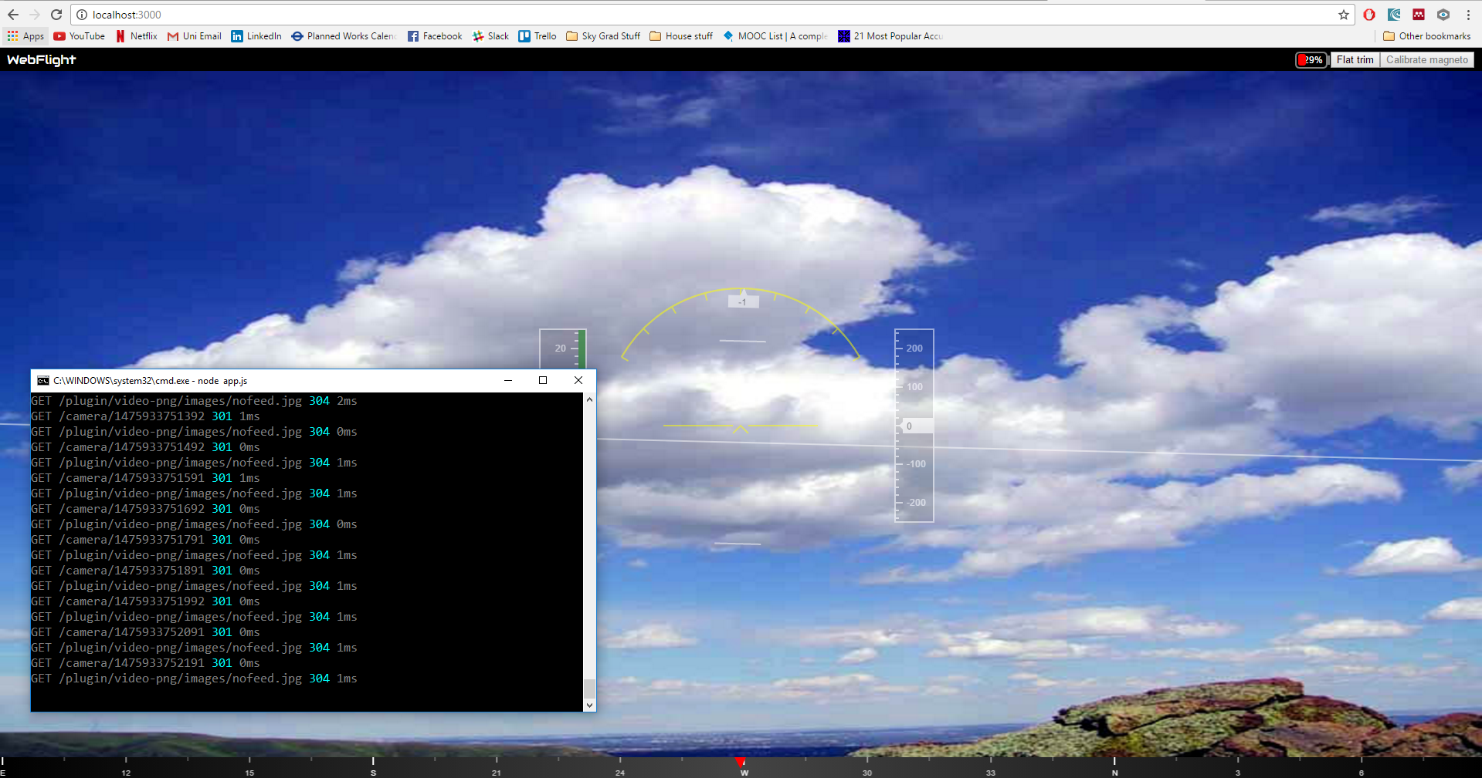

You’ll notice that your drone is (likely) not pointed at a nice view of clouds and whatnot, this is a stock image if you haven’t already guessed. The reason it displays this stock image is due to FFMPEG not being installed, this program is used to render images and videos from the drone so until we get that set up, we’re stuck staring at this!

However, it’s not all bad! We’ve got a nice HUD (Heads Up Display) including a compass along the bottom of the screen and some nice subtle instruments in the centre of the screen.

FFMPEG (FFS)

Downloaded FFMPEG (latest static 64-bit release) from here <https://ffmpeg.zeranoe.com/builds/>

Put it inside the ardrone-webflight folder and extracted it (right click, extract here). Renamed the extracted folder to ‘ffmpeg’

Good guide here <http://www.wikihow.com/Install-FFmpeg-on-Windows>